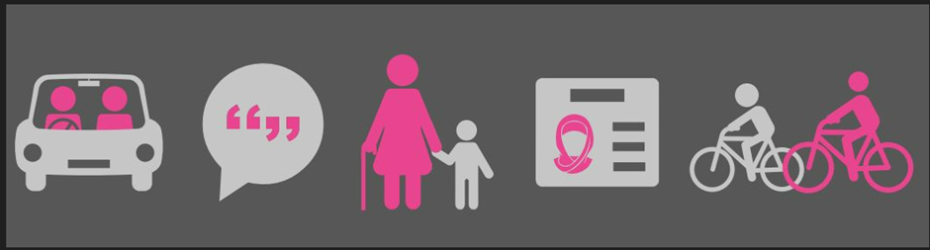
Post-16 Home to School Travel Service Bulletin February 2023
Home to school or college travel assistance for the academic year 2023/2024
There are no changes to the eligibility criteria for home to school travel assistance for eligible sixth form learners.
At its meeting on 15 February 2023, Council Cabinet approved the proposal that from September 2023 instead of arranging taxis and minibuses, the Council will replace them with Personal Travel Budget (PTB) payments for all eligible sixth form learners. This will be supported by a new and enriched Independent Travel Training (ITT) service to help and support more young people to become independent travellers. The Council’s ITT service will be delivered by Transition 2.
A PTB can be used in a variety of ways and provide a family with the flexibility to make travel arrangements to meet their own individual circumstances. For example,
- To purchase an annual bus pass(es)
- To cover or contribute towards fuel costs
- To cover or contribute to the cost of a taxi
- To cover or contribute towards childcare costs for younger siblings, to allow parents to take their post 16 young person to school or college
The Council recognises that there are learners of sixth form age for whom a PTB will not be suitable. Exceptional circumstances will be considered in line with the revised Post 16-19 home to school travel policy statement and based on any evidence provided by the parent to support the application.
A PTB will be calculated according to distance between the home address and the school or college and the number of days per week that an eligible sixth form learner is required to attend.
Independent Travel Training
The Council has a new and enriched independent travel training (ITT) offer, which many sixth form learners can benefit from. Delivery of the new ITT offer is by Transition 2 (T2) who are local experts in working with young people with Special Educational Needs and Disabilities (SEND). T2 are passionate about supporting young people to develop essential independence skills, including travel skills, so that they can reach their potential as adults, with access to appropriate education, employment opportunities and to enjoy social activities in the community.
Consultation Feedback
Following our recent Post 16-19 home to school travel assistance public consultation the majority of young people who attended the participation and engagement events said they thought that being given money to spend on travel costs (bus pass, petrol costs, taxi) is a good idea; also, that travel training would be helpful for them. Some young people also fed back that disability awareness training for bus drivers and taxi drivers would help them to feel more confident to travel independently.

We think this is great feedback!
Some direct quotes from young people in response to the consultation:

‘I want to travel on my own because It helps with our future so in the future we could live on our own without someone's help.’

‘I like the idea of independent travel’
Thank you to all the young people who participated in the engagement events. Your feedback is so important.
Applying for Post 16-19 home to school travel assistance
Who needs to apply?
Parents and carers of sixth form learners (year 12 and 13 upwards) must submit a new application every year.
When to apply
The application window opens on 1 April 2023.
How to apply
From 01 April 2023, parents and carers must complete an application, using the online application form, which can be accessed on the Council’s website Home to school travel - Derby City Council. This is the quickest way to apply and the preferred way for applications to be received.

Parents and carers will need to have a Derby City Council My Account to complete and online application form https://myaccount.derby.gov.uk/
Parents and carers will need to attach and upload any supporting information for example, evidence of free school meals or medical information to their online application. You will not be able to progress to the next stage of the application until the relevant documents have been successfully uploaded.

Parents and carers who do not have access to the internet on a smartphone, PC, or tablet device, can use the free computer and internet access, which is available at the Council House and at all Derby City Council library sites, to submit an online application.

Parents and carers who do not have access to the internet and cannot visit the Council House or their local Council library site, can contact the Home to School Travel Service and request a paper copy of the application to be posted to their address.
Telephone: 01332 642716 or email: schooltravel@derby.gov.uk

Completed paper applications and supporting evidence must be delivered to:
Home to School Travel Service
Derby City Council
The Council House
Corporation Street,
Derby DE1 2FS

How my application will be assessed

All applications will be assessed on an individual basis. The travel assistance offer for an eligible young person will take into account their individual needs and ensure the offer meet those needs. In most cases, the offer will be a bus pass, ITT, a mileage allowance or PTB .

Home to School Travel Assistance Post-16 Policy Statement 2023-2024
The Derby City Council Home to School Travel Service reviews its post-16 policy statement annually.
Publication of the post-16 policy statement for 2023-2024 is planned for week commencing Monday 27 March 2023.
For further information visit our website and our social media pages for all the latest information.
Home to school travel - Derby City Council
https://www.facebook.com/DCCLocalOffer/?locale=en_GB

