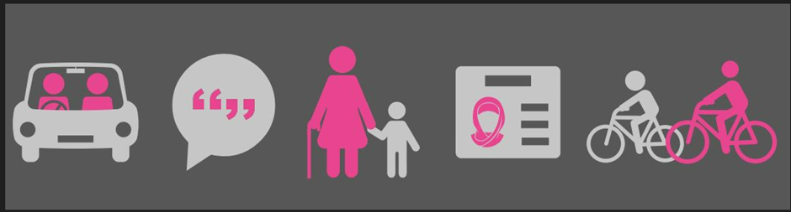

Home to School Travel Service Bulletin, March 2023

Home to School Travel Assistance Policy 2023-2024
The Derby City Council Home to School Travel Service reviews its policy annually.
This year, the Department for Education (DfE) has drafted statutory guidance for local authorities. Derby City Council has reviewed its policy in line with this DfE guidance.
There are no changes to the eligibility criteria for home to school travel assistance. Additions have been made (highlighted in yellow in the policy) to make it easier to understand. Examples are provided throughout the policy to demonstrate how the policy is applied and how decisions are made about what type of travel assistance will be offered to an eligible child or young person.
If you have any comments or feedback about the proposed policy, please email these to schooltravel@derby.gov.uk by Friday 24 March 2023.
Publication of the Home to School Travel Assistance Policy 2023-2024 is planned for week commencing Monday 27 March 2023.
Who needs to apply?
You will need to submit a new application for home to school travel assistance if:
- You are applying for home to school travel assistance for the first time.
- You have changed home address in the last year.
- Your child is starting a new school in September 2023.
- You are applying for a bus pass or applying to renew a bus pass (bus passes must be applied for every year).
If none of the above apply, and your circumstances are not changing, you do not need to complete an application and your child’s current travel assistance offer will remain in place. If your child currently has a seat in a taxi or minibus, the operator may change and parents/carers will be notified in advance of schools returning in September 2023.

When to apply?
The application window opens on 1 April 2023.
Applications for home to school travel assistance must be submitted by 31 May 2023, for the start of the new academic year. Parents are responsible for submitting applications by this deadline. Applications received after this date will be assessed and processed, but the Council cannot guarantee that travel assistance arrangements will be in place for the start of the academic year.

How to apply?
From 1 April 2023, parents must complete an application, using the online application form, which can be accessed on the Council’s website Home to school travel - Derby City Council. This is the quickest way for parents to apply and the preferred way for applications to be received. The online application portal will be available from 1 April 2023.
Parents and carers will need to have a Derby City Council My Account to complete and online application form https://myaccount.derby.gov.uk/
Parents and carers will need to attach and upload any supporting information, for example evidence of free school meals or medical information, to their online application. Parents will not be able to progress to the next stage of the online application until the relevant documents have been successfully uploaded.

Parents and carers who do not have access to the internet on a smartphone, PC, or tablet device, are encouraged to use the free computer and internet access available at the Council House and at all Derby City Council library sites, to submit an online application.

Parents and carers who do not have access to the internet and who cannot physically visit the Council House or their local Council library site, can contact the Home to School Travel Service and request a paper copy of the application to be posted to their home address.
Telephone: 01332 642716 or Email: schooltravel@derby.gov.uk

Completed paper applications and supporting evidence must be posted or hand delivered to:
Home to School Travel Service
Derby City Council
The Council House
Corporation Street
Derby DE1 2FS

How my application will be assessed
All new applications received will be assessed on a case-by-case basis by Home to School Travel Service officers, in line with policy. The individual needs for an eligible child will be considered and a suitable travel assistance offer will be made to meet need.

Exceptional Circumstances

Exceptional circumstances will be considered, in line with policy and based on any evidence provided by the parent, to support the application; for example, medical evidence. The decision about the travel assistance offer for an eligible child will be at the discretion of the Council.

The Council will consider the following as exceptional circumstances, and a seat in a taxi or minibus may be offered:

- An eligible child has complex medical needs that require trained staff to accompany the child to school, where there is a need for medical intervention during the journeys to and from school, for example:
  - A child requiring oxygen
  - A child requiring suction

- An eligible child is not physically able to walk to school, due to their Special Educational Needs and Disabilities (SEND); public transport is not suitable and there is no vehicle available for the parent to be offered a mileage allowance. There is no other way for the parent to get their child to school.

- An eligible child is placed at an out of area setting; the distance means that travel by public transport is not feasible; there is no vehicle available, for the family to be offered a mileage allowance, to get their child to school.

- The parent of an eligible child has a medical/health condition, which prevents them from being able to accompany their child to school. It would be unreasonable to expect the child to walk to school or travel on public transport unaccompanied. Current medical evidence must be provided.

The Council does not consider the following to be exceptional circumstances:

- The parent of an eligible child is employed and needs to get to work (this includes parents who work from home).

- The parent of an eligible child has another child or children who need to get to a different school(s).

- Parents’ other social, family, or caring commitments.

Please note: The home to school travel assistance offer will be a bus pass, ITT, or a mileage allowance for all eligible children, for whom there are no exceptional circumstances.

Please visit our website and our social media pages for all the latest information.
Home to school travel - Derby City Council
https://www.facebook.com/DCCLocalOffer/?locale=en_GB

