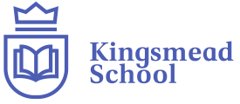
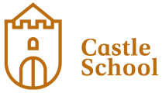
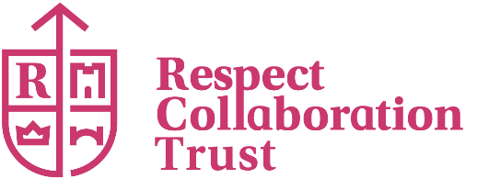

Respect Collaboration Trust- Consultation
Consultation:
- Castle School: Site Removal and Increased Places 60 to 100
- Kingsmead School: Additional Satellite Site
Since April 2021 a number have changes have been made to what is now known as Respect Collaboration Trust, this is in direct response to the increase demand locally and pressure on Derby City Special Schools, supporting Derby City to reduce out of authority placements and an increase in exclusions. This consultation supports bringing this wider project together as a whole, to offer a greater number of SEMH placements for Derby City.
Already the collaboration has;
- Extended the age ranges (5-16) and pupil numbers (150) at Bridge Street School
- Extended the age ranges (7-19) and pupil numbers (180) at Kingsmead School
- Extended the age ranges (5-19) and pupil numbers (100) at Castle School
- Created Respect Collaboration Trust
- Implemented an Inclusion Advisory Service
- Redeveloped and taken ownership of a number of buildings to provide school based activities and also outreach work, this includes St James House and Darley Barn
Proposal 1
Remove the Cedar Grove building as part of the Castle School, this is in response to Castle School moving to St James House, Mansfield Road, Derby on 13th February 2026
The removal of the Cedar Grove estate from Castle School has no detrimental impact on Castle School community including the children who attend it, as the new building that pupils have already moved into is bigger in size, offers a wider range of facilities which are suitable to the age ranges that Castle School caters for.
Proposal 2
Increase the capacity number of Castle School back to 100 pupils, this forms part of the Derby City’s Inclusion Strategy to allow for 100 pupils to attend the Castle School at St James House. The school has already been previously commissioned by Derby City Council for 100 pupils and Castle School has capacity for up 100 pupils.
Proposal 3
Formalise the arrangements for a Key Stage 2 Satellite Site for Kingsmead children at Cedar Grove. This building prior to the Castle School inhabiting it was a building utilised by Newtons Walk children (aged 5-11) and has been inhabited by a cohort of children since 23rd February 2026, and has been a successful, therefore is suitable for this cohort of pupils.
We propose Kingsmead School will admit up to 40 children through the schools defined admissions process and land will be transferred appropriately. Again, this forms part of Derby City’s Inclusion Strategy.
We will seek the views of stakeholders across the sector.
Please respond using the attached form by 25th May 2026 9am, this provides a four- week opportunity for people to respond to our proposals. If you would like to discuss any specific aspects of the proposal or need further information, please contact;
Executive Assistant and Office Manager
Respect Collaboration Trust
Unit 16, Victoria Way, Pride Park, Derby DE24 8AN

Proposal to;
- Castle School: Site Removal and Increased Places 60 to 100
- Kingsmead School: Additional Satellite Site
CONSULTATION RESPONSE FORM
We are very interested in your views and comments on this proposal. Please use this form to let us have your views. (Please use extra sheets if you wish).
Do you support the above three proposals as shown in the consultation document?
I support the proposal. □
I’m undecided about the proposal. □
I don’t support the proposal. □
I support some elements of the proposal but not others □
Comments;

Date………………………………………………………………………………..

Status………………………………………………………………………………
(For example, a parent, governor, school, agency, other)
Please return your completed form to: Executive Assistant and Office Manager, Respect Collaboration Trust, Unit 16, Victoria Way, Pride Park, Derby DE24 8AN
All responses will be treated confidentially.
The closing date for getting your views and comments in is 25th May 2026 9am.

